

**The University of Azad Jammu and Kashmir,**

**Muzaffarabad**

|  |  |
| --- | --- |
| Name | Kamal Ali Akmal |
| Course Name | Computer Architecture and Logic Design |
| Submitted to | Engr. Sidra Rafique |
| Semester | 2nd |
| Session | 2024-2028 |
| Roll No | 2024-SE-38 |
| Lab No | 05 |
| Submission date | 09 August 2025 |

**Full Adder:**

A full adder is a combinational logic circuit that adds three input bits (A, B, and a carry input, Cin) and generates two outputs: a sum (S) and a carry out (Cout).

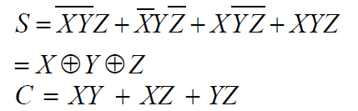

The truth table for a full adder is as follows:

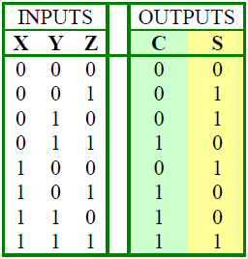

Figure . Full Adder Truth Table

**Logic Expressions**

* **Sum** = A ⊕ B ⊕ Cin
* **Cout** = (A ⋅ B) + (B ⋅ Cin) + (A ⋅ Cin)

**Implementation**

* Can be built using two **Half Adders** and one **OR** gate.
* Widely used in multi-bit binary addition by connecting several full adders in series (Ripple Carry Adder).

**Applications**

* Arithmetic Logic Units (ALUs)
* Digital calculators
* Processors and microcontrollers
* Multipliers and digital signal processing

**Truth Table (Sum)**

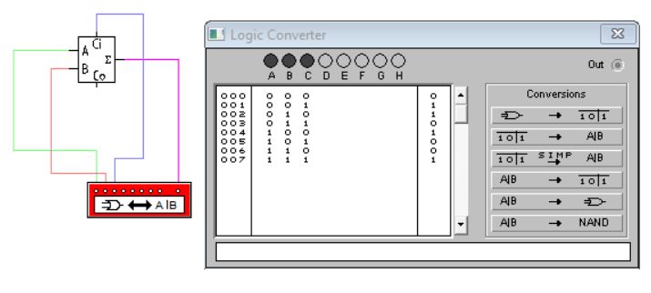

**Truth Table (Carry)**

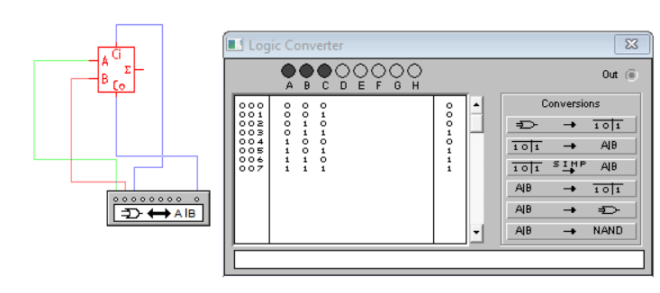

**Circuit Diagram & Equation (Sum)**

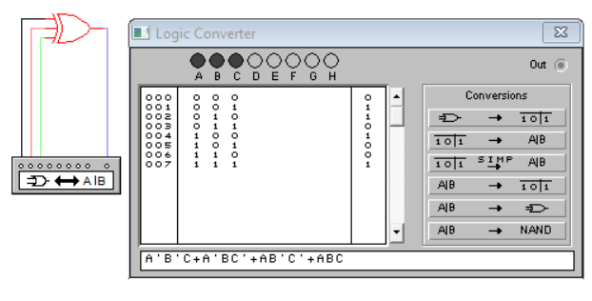

**Circuit Diagram & Equation (Carry)**

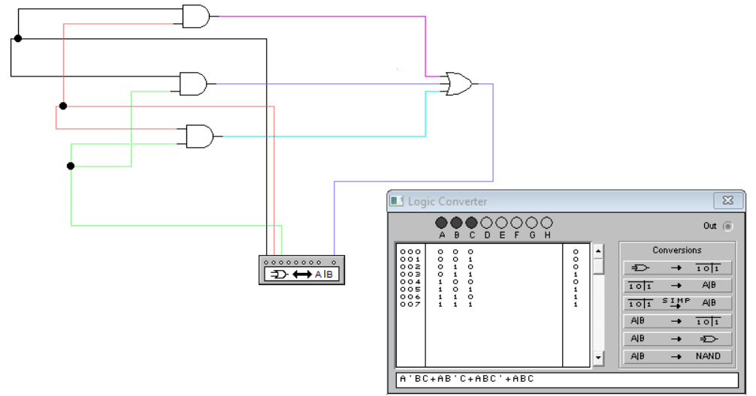

**1) Half Subtractor**

The half-subtractor is a combinational circuit which is used to perform subtraction of two bits. It has two inputs, A (minuend) and B (subtrahend) and two outputs Difference and Borrow. The logic symbol and truth table are shown below.

**Figure-1: Logic Symbol of Half subtractor**

Figure-2: Truth Table of Half subtractor

**Figure-3: Circuit Diagram of Half subtractor**

From the above truth table, we can find the Boolean expression.

**Difference = A ⊕ B  
Borrow = A' B**

From the equation we can draw the half-subtractor circuit as shown in figure 3.

**Truth Table & Equation (Difference)**

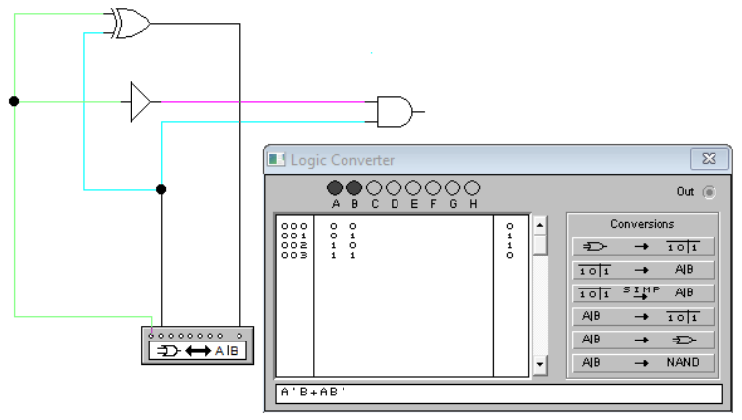

**Truth Table & Equation (Borrow)**

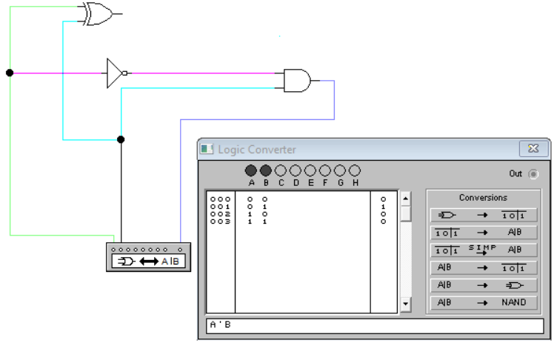

**2) Full Subtractor**

A full subtractor is a combinational circuit that performs subtraction involving three bits, namely A (minuend), B (subtrahend), and Bin (borrow-in) . It accepts three inputs: A (minuend), B (subtrahend) and a Bin (borrow bit) and it produces two outputs: D (difference) and Bout (borrow out). The logic symbol and truth table are shown below.

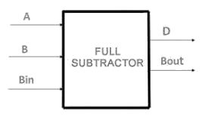  
**Figure-4: Logic Symbol of Full subtractor**  
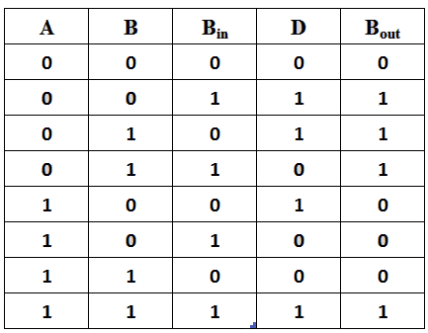  
**Figure-5: Truth Table of Full subtractor**

From the above truth table we can find the boolean expression.

**D = A ⊕ B ⊕ Bin  
Bout = A' Bin + A' B + B Bin**

From the equation we can draw the Full-subtractor circuit as shown in the figure 6.

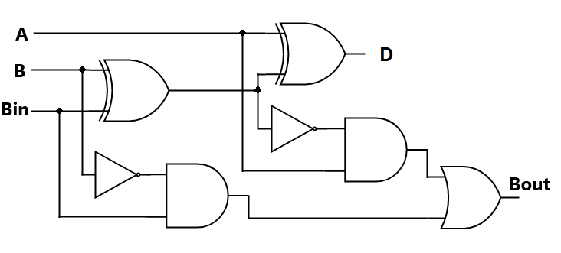  
Figure-6: Circuit Diagram of Full subtractor.

**Circuit Diagram & Equation (Difference)**

**Circuit Diagram & Equation (Borrow)**

